Eighth Grade Science Syllabus 2016-2017
Teacher: Mr. Haithcock
Telephone: (919) 404-3630 (school)
E-mail: Still waiting to receive email but will be sent home with child when I receive it
Website: http://Haithcock.weebly.com
Typical Office Hours (varies with meetings): Daily planning 9:36am to 10:17am
Planning 11:13am to 11:54am
After school: Set up appointment
*Parents/ Guardians, feel free anytime to set up conferences

Tutoring: Upon request

Dear Parent/Guardians:

I would like to take this opportunity to introduce you to myself, to share some of my academic expectations, and to explain the classroom discipline plan that is utilized in Eighth Grade Science. As your child’s teacher, I am so very excited about this year as well as the subject we will be studying. I sincerely hope your student will share this enthusiasm. Please encourage your student to always do the best they can at whatever level that may be. Within this packet are some suggestions to make this school year more successful. Please discuss as a family ways these tips can be applied to your home situation. If your child needs help after school, we can set up dates that will work for both the student and I. Points of contact are listed above, with in addition of Remind text sign up, found in this packet.

Your child’s success in science is important to me. Our communication about their progress can be detrimental to his/her success. With that being said, I have attached colored sheet(s) is what I required to be filled out and make it back to me. This includes: contact information, technology survey, about your child information, and general educational contract.

To begin our enticing time together in Eighth Grade Science, let me go through a quick introduction about myself:

About Me:
I’m excited to be a part of the Zebulon Magnet M.S. for the Gifted and Talented family as an 8th Grade Science teacher. I have worked with all age levels and I truly enjoy educating young minds at work every day. I am excited to work with you and get to know each and every one of you better.
My Education
North Carolina State University: BA in Science Education Grades 6-9 (August 2016) [*GO PACK!*]
Certification: Teaching License Middle Grades Science 6-9: (August 2016)
Fun Facts
I play disc golf quite often.
I have a cat named Piper.
I’m originally from Snow Camp, North Carolina
Why I became a Teacher
When I was in High School I had an Environmental Science teacher that was truly inspiring. I had initially wanted to go into physical training to work for a pro baseball team but at the last second I ran with my passion for science which landed me at N.C. S.U. I have always loved teaching as I have been a part of many baseball camps and enjoyed seeing the face of success when these kids felt accomplished by doing something right. My student teaching at Holly Grove Middle School engraved this passion of teaching as my experience there was awe inspiring to say the least. I really am looking forward to having a similar experience here at ZMS.
My Teaching Philosophy
My beliefs on teaching are short and simple- Everyone Can. I believe that if someone is willing to do something or learn or grow then everyone can accomplish, everyone can succeed, everyone can grow. It is my philosophy that what students are exposed to and develop when they're younger can have an enormous impact on the rest of their lives and it is my mission to instill in my students the belief that they too can do anything they set their mind to, and with my help I hope to guide them along that path.
Course Description:
Eighth grade science builds on the concepts and skills acquired in kindergarten through seventh grade. Connections to mathematics, technology, social studies, and communication skills will be an integral part of this course. The specific competency goals that are covered in eighth grade science are: scientific inquiry, basic chemistry, energy conservation and transfer, the hydrosphere, Earth’s history, epidemiology, biotechnology, ecosystems, evolution, and molecular biology. A complete and detailed listing of the specific goals and objectives can be found on the North Carolina Department of instruction website at the following address: http://www.dpi.state.nc.us/docs/acre/standards/new-standards/science/6-8.pdf

Requirements:
Every student is expected to come to class prepared (INBs, paper, pencils, and all unfinished classwork done) and ready to work everyday. Grades will be posted in the classroom, weekly and by lunch number, so that students can self-manage grades. In class, we will be doing a number of experiments throughout the semester. Some of the experiments may be done as a class, some may be done in small groups, and some may be done individually. At least one of these experiments will be formally done and then presented. This large project will be known as our Genius Hour project.

To include, students must bring their INBs (Interactive Notebooks) home and to class every day. INB’s are very important resource for each student. All notes and practice will be kept in their INB’s. Students take notes during class on the right side of the notebook (input) and practice the skills they have learned on the left side of the notebook (output). Students should bring his/her INB’s to class and home with them each day. They need to review their notebooks for: 10 minutes, every 24 hours, for 7 days a week
Their INB will become everything for class. It is their textbook, class notes, study guide, and more.

Attendance:
Attendance and participation in all classes is expected of all students. However, life often has a habit of throwing something unexpected in our paths. If you miss or are going to miss a class, please contact the teacher as soon as possible. You will, of course, be responsible for completing any missed work (check the INB Master Copy or a responsible classmate for what we did in class and what the assigned work was). Much of the learning will be a result of participation, discussion, and in-class activities, therefore your attendance in class is extremely important.

Assessment and Grading:
The purpose of education is learning. The purpose of assessment is for the teacher to evaluate how much and how well you have learned the material as put forth in the NC standard course of study.

Students will do in class assignments, quizzes, and tests to assess the student’s learning. Any work done is located in the INB. So do not lose this!

INB grading days and grade breakdown is as follows:
Input | Output
EQ, date, pg # 2pts. | Demonstrating of processing  *Left side varies depending on lesson 5pts.
Notes 5pts.
HOT questions (level 2 and 3) 4pts.
Summary (2-3 sentences) 4pts.

Notebook checks will be on Fridays and will have one lesson checked weekly.

Your grade will be based on a school wide implementation, which includes tests and quizzes. These assessments indicate how well you "know" the curriculum and your grade should be a reflection of your mastery of the curriculum. Your “homework”, in class assignments, and other projects will also be counted as a grade because they also show your mastery of the curriculum. If your grade is not as high as you would like it there are two things you can do to improve your grade. First, make sure all of the assignments are completed and turned in. Secondly, the quizzes and tests may be retaken to improve your grade, as long as the proper steps for retake are followed. Students may see me for retest procedures. All assignments and assessments will be based on the specific goals and objectives that can be found on the North Carolina Department of Instruction website at the following address: http://www.dpi.state.nc.us/docs/acre/standards/new-standards/science/6-8.pdf

Also, students will participate in Genius Hour every other week for an entire period, if all other work is completed. After mini-lessons on what is appropriate, students will choose a topic to study with Teacher Approval. Students will be given time in class to work on the project with the teacher serving as a Facilitator. The Facilitator will provide research materials (ie., books, computer, iPads, etc.) for students to explore. As an end project, students must present their topic to an audience. Some general questions about Genius Hour is answered below:

What is Genius Hour?
Genius Hour is time set aside in class for students to study their passion on a new idea or skill once a week for a set amount of time.

Why is Genius Hour important?
Students take ownership in their own learning. They learn about something they want to learn about. Genius Hour sparks curiosity, and students have an opportunity to become their own Genius. Genius Hour encourages life-long learning, imagination, perseverance, self-awareness, adaptability, as well as other life-lessons.

What Common Core State Standards does Genius Hour support?
Students must choose a topic that covers at least one of the units taught in 8th grade science. A list of units covered is located in this course syllabus.

Additional standards covered:

Science: 8. P.1.1- Scientific Inquiry and Technological Tools: Scientific process and experimental design; Lab safety and equipment. Inferences vs. Observations, Collecting qualitative vs. quantitative data; Analyze and communicate data; Prepare models or computer simulations; defend conclusions; Utilize technology to collect and analyze data; Technological design

English: 8.W.5- Conduct short research assignments and tasks to build knowledge about the research process and the topic under study. Formulate a research question; gather relevant information from multiple sources, using search terms effectively, and annotate sources; assess the credibility and accuracy of each source; Quote or paraphrase the information and conclusions of others; Avoid plagiarism and follow a standard format for citation; Present information, choosing from a variety of formats.

Math: MP.1- Make sense of problems and persevere in solving them.

Social Studies: 8.H.3.2- Explain how changes brought about by technology and other innovations affected individuals and groups in North Carolina and the United States (e.g. advancements in transportation, communication networks, and business practices.)

Overall Grading:
Homework/ Peer-Self Reviews:  10% | Quizzes/ Labs/ Small Projects:  30% | Tests/ Large Projects/ Genius Hour:  40% | Classwork/ INB’s:  20%

Academic Integrity:
One of the goals of Zebulon Middle School is to foster a spirit of complete honesty and a high standard of academic integrity. The attempt of any student to present as their work they have not honestly performed is regarded by the teacher and administration as a serious offense with severe consequences. We expect all students to act in a manner that does not infringe upon the rights of others. Students have the right to an education free from fraudulence and dishonesty. It is the responsibility of each student to help maintain such a learning society. The school expects that all students will refrain from cheating, plagiarism, collusion and lying.

Reminders of Student Expectations:
At Zebulon, students are expected to behave and conduct themselves in such a manner as not to disrupt the normal educational process and to continue their growth toward maturity and self-responsibility. Each student needs to assume an active role in his/her educational program to make it a meaningful experience.
- Be considerate, courteous and respectful. Inappropriate behavior include rudeness, back talk, swearing, name-calling, putdowns, etc.
- Listen to and follow directions of: teachers, administrators, custodians, secretaries’ instructional assistants, substitutes, and other adults in authority.
- Follow classroom and school rules.
- Be on time and prepared for class. Bring INBs, paper, pencils, and other necessary classroom materials.
- Walk in an orderly manner on campus. Inappropriate behavior includes: running, yelling, pushing, shoving, kicking, tripping, hitting, horseplay, play fighting, interfering with the flow of traffic, congregating or moving around in large groups.
- Keep hands, feet, and objects to themselves. Inappropriate behavior includes: pushing, shoving, kicking, tripping, hitting, horseplay, play fighting. Public displays of affection are not appropriate
- Show respect for school property and the property of others. Inappropriate behavior includes: writing on or scratching school or other people’s property, or taking things without asking to borrow or use them.
- Bring problems and concerns to the attention of an adult. Inappropriate behavior includes: talking about others, spreading rumors or hearsay, confronting other students.
- Use materials appropriately. Protect and respect school and personal equipment.
- Stay in designated areas. Once on campus students are to remain in supervised areas

Things you as a Parent Can do at Home to help your Child:
As a parent, you are your child's first and most important teacher. When parents and families are involved in their children's schools, the children do better and have better feelings about going to school. In fact, many studies show that what the family does is more important to a child's school success than how much money the family makes or how much education the parents have. There are many ways that parents can support their children's learning at home and throughout the school year. Here are some ideas to get you started!
- Meet the teacher: I am happy to meet each and every one of you! As parents/ guardians, you have the biggest impact on the students’ learning process. Please don’t hesitate to contact me
- How to sign up for remind and remind code is located right here

- Attend parent-teacher conferences and keep in touch with your child’s teacher.
- Make sure that your child gets INB done.
- Help your child prepare for tests. Tests play an important role in determining a student’s grade. Your child may also take one or more standardized tests during the school year, and your child's teacher may spend class time on test preparation throughout the year. As a parent, there are a number of ways that you can support your child before and after taking a standardized test, as well as a number of ways you can support your child's learning habits on a daily basis that will help her be more prepared when it's time to be tested.
- Learn what the schools offers. Read the information the school sends home, and ask to receive information in your native language if necessary. Talk to other parents to find out what programs the school offers. Maybe there's a music program, after-school activity, sports team, or tutoring program your child would enjoy. Remember to keep track of events throughout the school year.
- Volunteer at your child’s school and/or join your school’s parent-teacher group. Teachers appreciate it when parents help out at the school! There are many ways you can contribute. You can volunteer in your child's class or in the school library. You can make food for a school event. If you work during the day, you can attend "parents' night" activities or your child's performances. At most schools, a group of parents meets regularly to talk about the school. This group is usually called the PTA or PTO. The meetings give you a good chance to talk with other parents and to work together to improve the school.
- Ask Questions. If something concerns you about your child's learning or behavior, ask the teacher or principal about it and seek their advice. Your questions may be like these — what specific problem is my child having with reading? What can I do to help my child with this problem? How can I stop that bully from picking on my son? How can I get my child to do homework? Which reading group is my child in?
- Let the school know your concerns.
- Demonstrate a positive attitude about education to your children. What we say and do in our daily lives can help them to develop positive attitudes toward school and learning and to build confidence in themselves as learners. Showing our children that we both value education and use it in our daily lives provides them with powerful models and contributes greatly to their success in school.
- Encourage your children to read. Helping your child become a reader is the single most important thing that you can do to help the child to succeed in school-and in life. The importance of reading simply can't be overstated. Reading helps children in all school subjects. More important, it is the key to lifelong learning.
- Talk with your child. Talking and listening play major roles in children's school success. It's through hearing parents and family members talk and through responding to that talk that young children begin to pick up the language skills they will need if they are to do well. For example, children who don't hear a lot of talk and who aren't encouraged to talk themselves often have problems learning to read, which can lead to other school problems.
- Encourage your child to be responsible and work independently. Taking responsibility and working independently are important qualities for school success. You can help your child to develop these qualities by establish reasonable rules that you enforce consistently, making it clear to your child that he has to take responsibility for what he does, both at home and at school, showing your child how to break a job down into small steps, and monitor what your child does after school, in the evenings and on weekends. If you can't be there when your child gets home, give her the responsibility of checking in with you by phone to discuss her plans.
- Encourage active learning. Children need active learning as well as quiet learning such as reading or doing homework. Active learning involves asking and answering questions, solving problems and exploring the natural world. To promote active learning, listen to your child's ideas and respond to them. Let him jump in with questions and opinions when you read books together. When you encourage this type of give-and-take at home, your child's participation and interest in school is likely to increase.

Parent Portal:
Do you want to be able to keep up with your child’s grades, attendance and discipline throughout the year instead of having to wait on a report card or contact from a teacher? Then you need a Parent Portal account.

Home Base is a statewide student information system that replaced NCWISE and SPAN starting in the 2013-14 school year. Home Base gives parents and students access to real-time information including attendance, grades and assignments. With Home Base, powered by Pearson's PowerSchool application, everyone stays connected: Students stay on top of assignments, parents are able to participate in their child's progress, and teachers can instantly share information from their gradebook with parents and students. Families with multiple students can also set up their accounts to view all of their students at one time, with one login.

Forms are available in the main office or can be downloaded from the link on the left side of this page.

PTA Information-ZMS “Go Fund Me”:
What a great opportunity to show your support of your student and our school!
We are raising funds to purchase computers for our school. During a computer upgrade in 2014-15 school year we lost 211 computers as they were too old to be upgraded. These computers were not replaced by the school system.
We are attempting to replace 20 computers for our students. This will give our students the opportunity to utilize technology in the classroom to prepare them for the future.
Visit: http://www.gofundme.com/44b4h55g

General Science Timeline:

August Review the scientific method

September Ecosystems

October Hydrosphere

November Molecular Biology

December Structures and Functions of Living Organisms

January Energy: Conservation and Transfer

February Matter: Properties and Change

March Earth’s History

April Evolution and Genetics

May and June EOG review and testing

*This is what I expect to be covering each month. Some changes will be necessary as our schedule changes, especially inclement weather during the winter months.

Please fill out all the colored pages and return be Friday, September 2nd, 2016.

Your Child’s Name: _________________________________________________

Parent/Guardian Name: ___________________________________________ relationship to student _____________________________
___________________________________________ relationship to student _____________________________

--Contact information--
Phone/Cell: primary (________) _________________________ ; ask for _________________________
Secondary (________) _________________________; ask for _________________________

E-mail: ___________________________________________@_____________________________

Preferred method of contact:
e-mail phone letter home text other (list under additional information)

Any additional information I must know? (i.e.- restricted times of contact, preferred days etc.) ________________________________________________________________________________________________________________________________________________________________________________________________________________________________________________________________________

Technology Survey:
As a magnet program that focuses on math, science, and technology, Zebulon Middle has adopted the Bring Your Own Device policy, BYOD. BYOD policies permit students to bring personal devices, such as net books, computers and smart phones to school for classroom purposes. At Zebulon, in the previous school year, the BYOD policies were piloted into a few classrooms and is continuing to expand. By permitting devices in the classroom with BYOD policies, students have access to technology on an individual basis and teachers are able to provide more digital lessons.
In my classroom, ideally, aiming more towards a Flipped Classroom, which inverts traditional teaching methods, delivering instruction online outside the classroom and moving “homework” into the classroom. Students will watch lectures at home and at their own pace, communicating with peers and teacher via online discussions. Also, concept engagement takes place in the classroom with the help of the instructor.

For more information, please visit: https://www.knewton.com/infographics/flipped-classroom/

By completing this survey, this helps gage how the classroom will run and if the Flipped Classroom can work. Alternative instruction can be provided for students without home internet access or devices.

What kind of technology is available to your child at home?

☐ Desktop
☐ Laptop
☐ Ipad/tablet
☐ Ipod
☐ Ipod touch
☐ Digital camera
☐ Smartphone
☐ The technology we have is for adult use only
☐ We do not own any of these devices

Do you have internet access at home? Yes or No

If I were to assign technology based homework as an alternative to written assignments, would you allow your child to use the computer to complete these assignments at home? Yes or No

Are you familiar with QR codes? Yes or No

Would you be interested in learning more about educational websites and apps for your child? Yes or No

Any other concerns or questions: ________________________________________________________________________________________________________________________________________________________________________________________________________________________________________________________________________
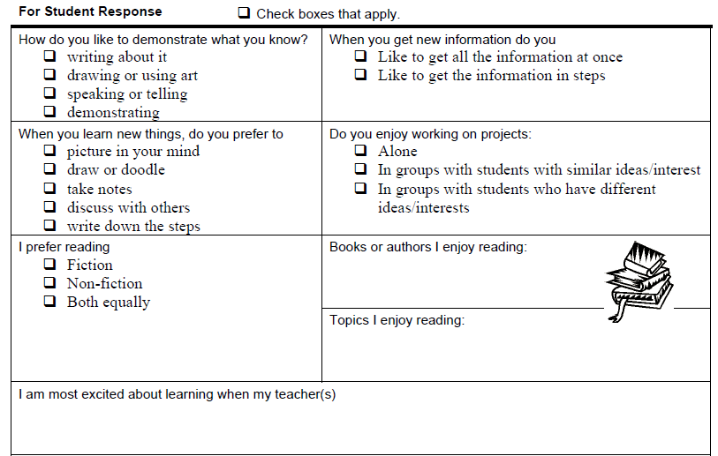
Additional information you would like to add about yourself:
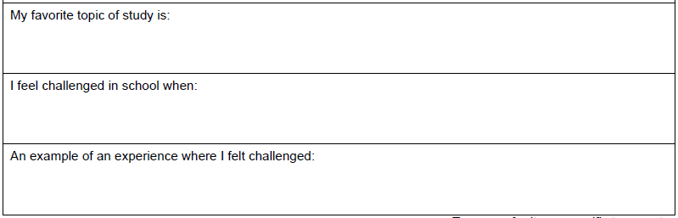

Parents/ Guardians, this page is to best get to know your child. This section is optional, but strongly recommended for instructional purposes to best understand your child’s instructional needs/wants.
I value your input and communication.
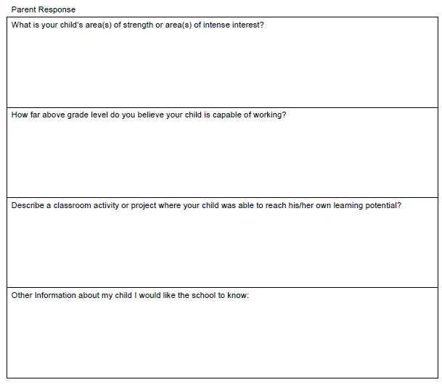

As a parent/guardian, I will:
•Show respect & support for my child, the teachers, & the school.
•Support the school’s and teacher’s discipline policy.
•Provide a quiet, well-lit place for study & supervise the completion of homework.
•Attend parent-teacher conferences.
•Talk with my child each day about his or her school activities.
•Work closely with my child’s teacher in creating a successful learning atmosphere.
•Encourage my child to read for at least 15 minutes each day & let my child see me read.

As a student, I will:
•Always try to do my best work.
•Be kind and helpful to my classmates.
•Show respect for myself, my school, & other people.
•Obey classroom, school, & bus rules.
•Show respect for property by not stealing or vandalizing.
•Come to school prepared with my homework & my supplies.
•Believe I can and will learn.
•Spend at least 15 minutes each day studying or reading at home.
•Talk with my parents each day about my school activities.

As a teacher, I will:
•Show respect for each child & for his or her family.
•Make efficient use of learning time.
•Provide a safe and comfortable environment that’s conductive to learning.
•Help each child grow to his or her fullest potential.
•Provide meaningful & appropriate homework activities.
•Provide necessary assistance to parents so they can help with assignments.
•Enforce school & classroom rules fairly & consistently.
•Supply students & parents with clear evaluations of progress & achievement.
•Use special activities in the classroom to make learning enjoyable.
•Demonstrate professional behavior and a positive attitude.

Together, as partners in education, we will carry out the terms of this contract and syllabus.

Please sign this contract if you have read and understand the syllabus/ social contract.

__________________________ __________________
Parent/Guardian’s Signature Date

____________________________________________
Student’s Signature Date

____________________________________________
Teacher’s Signature Date

